***PAAREES PERFUMES***

***THIERRY MUGLER***

***FOR UNISEX***

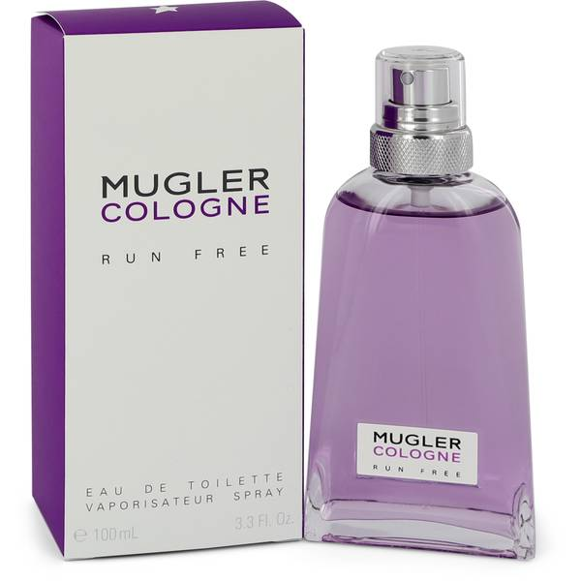

# 

# MUGLER RUN FREE

## *Description:*

Mugler Run Free by Thierry Mugler Perfume. Suitable for both women and men, Mugler Run Free perfume is a light, simple fragrances that is composed entirely of only two ingredients. A bold combination of purple ginger and akigalawood, this aroma is smokey and woody with a fresh spicy overtone. Purple ginger opens the fragrance with an herbaceous, slightly spicy scent. Akigalawood forms the base of the perfume and incorporates the woody and smoky undertones that balance out the earthiness of the ginger. Launched in 2018, this simple fragrance is light enough for casual wear yet bold enough for evening occasions.